***CODE TESTING***

**AUTOMATED ATTENDANCE SYSTEM**

**TEAM JAK OF ALL TRADES**

**Members:**

Allen Jean B. Lagangga

Jessa M. Diano

Kent Christian Lurado

***May 20, 2025***

1. **Register Testing**

Testing the functionality of user registration. It ensures that new users (students or instructors) can create accounts with valid input, and that invalid inputs are properly rejected.

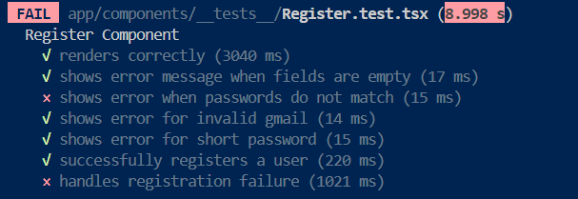 **Fail:**

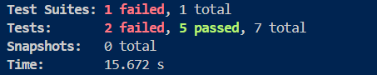

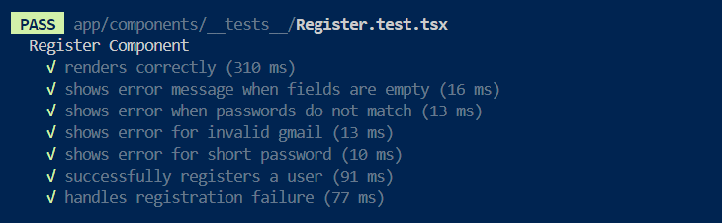 **Success:**

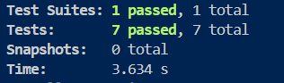

1. **Sign In Testing**

This test verifies the login process. It checks whether users can successfully sign in with valid credentials and are prevented from accessing the system with incorrect login details.

**Fail:**

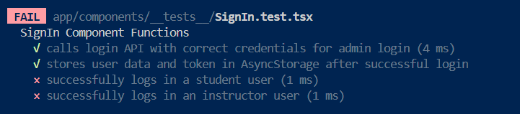

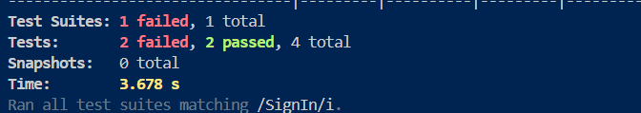

**Success**

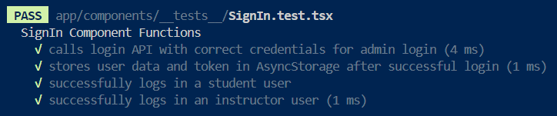

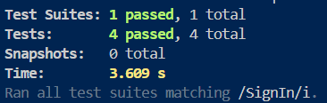

1. **Instructor Registration Testing**

This test focuses on testing the specific registration process for instructors. Ensures that the system accepts valid instructor details and rejects incomplete or invalid inputs.

**Fail:**

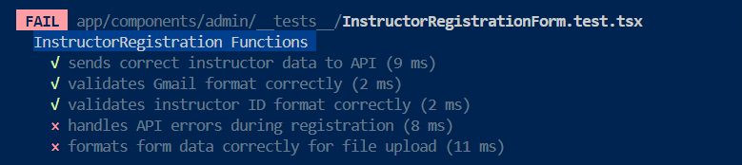

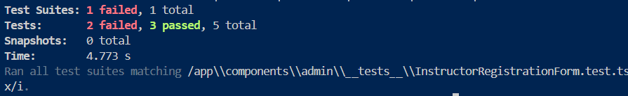

**Success:**

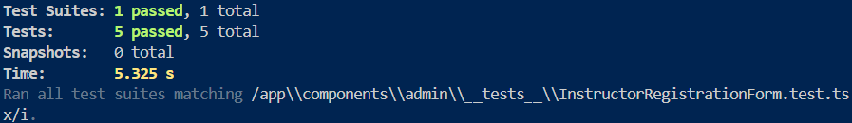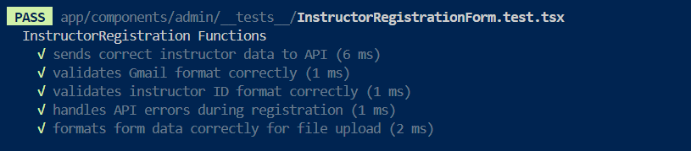

1. **Student Registration Testing**

This test ensures students can be registered into the system correctly. Tests for proper data validation and correct handling of errors during student account creation.

**Fail:**

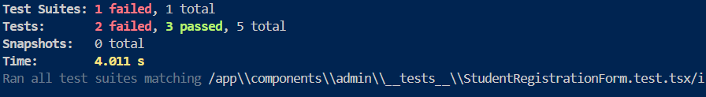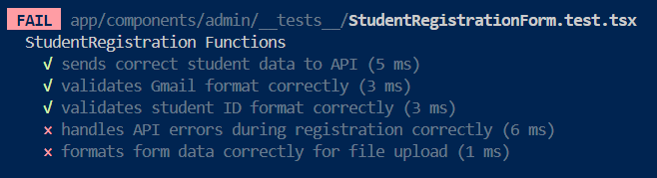

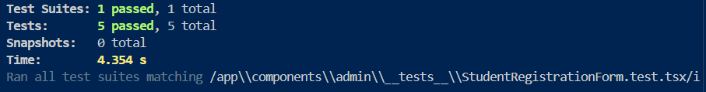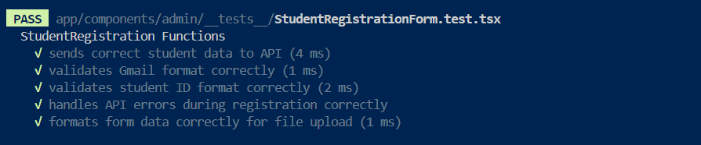 **Success:**

1. **Instructor Management Testing**

This tests the functionalities related to managing instructor data, such as viewing, editing, or deleting instructor profiles.

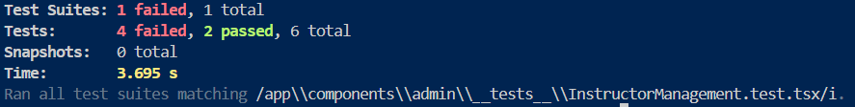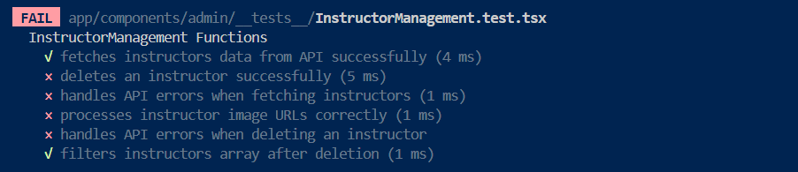 **Fail:**

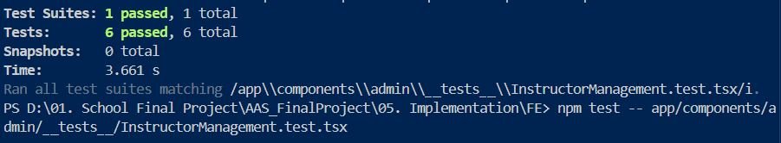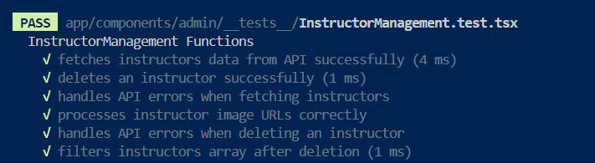 **Success:**

1. **Student Management Testing**

This test checks the management capabilities for student data, including updates to personal information and account control actions by admins.

**Fail:**

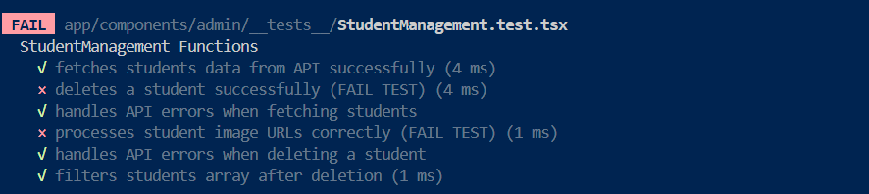

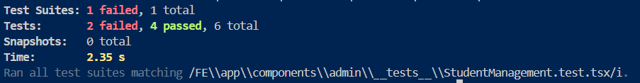

**Success:**

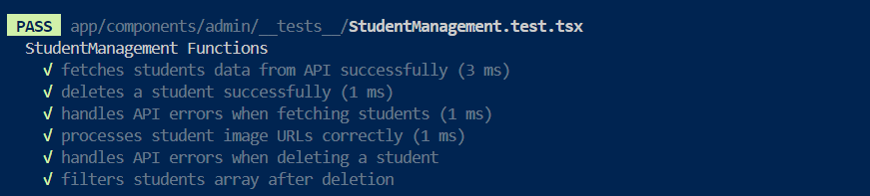

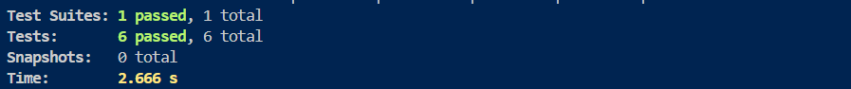

1. **Course Registration Testing**

This test validates the functionality to register or create new courses in the system. This includes input validation and error handling for course details.

**Fail:**

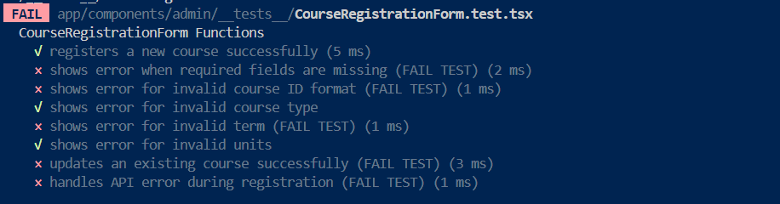

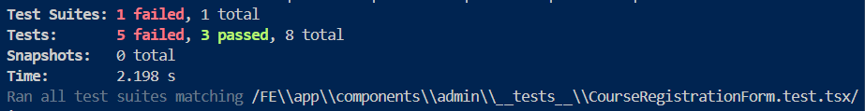

**Success:**

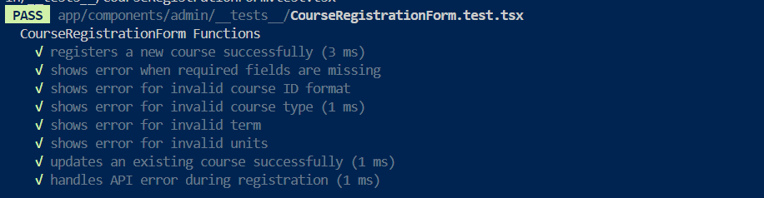

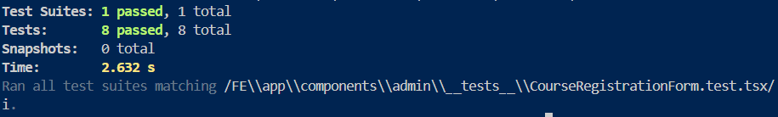

1. **Course Management Testing**

This test covers the ability to manage existing courses. This might include editing course information, archiving, or deleting courses.

**Fail:**

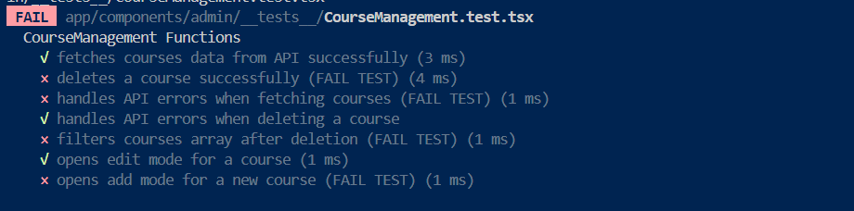

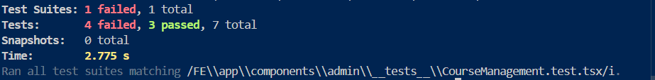

**Success:**

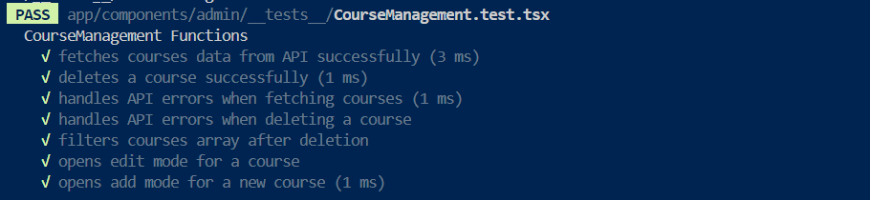

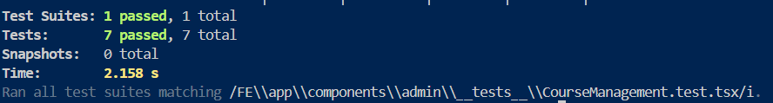

1. **Assign Courses Testing**

This tests the process of assigning courses to instructors or students. Ensures correct mapping and handling of related data.

**Fail:**

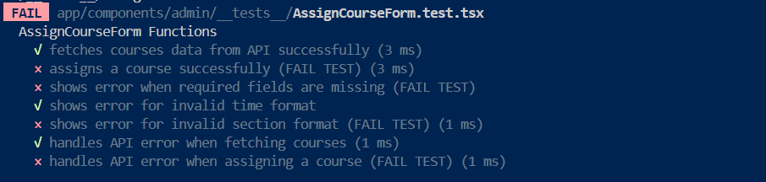

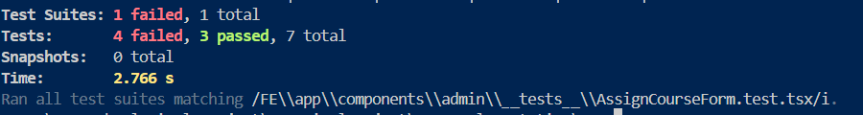

**Success:**

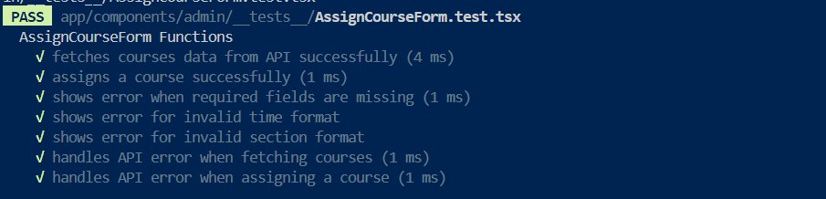

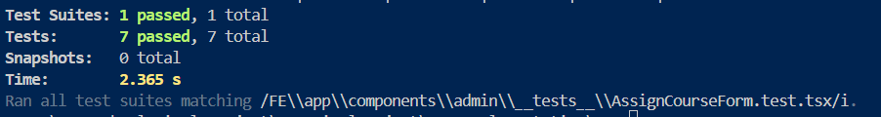

**10. Enroll Student Testing**

This test ensures that students can be successfully enrolled in assigned courses. Validates proper linking between students and courses.

**Fail:**

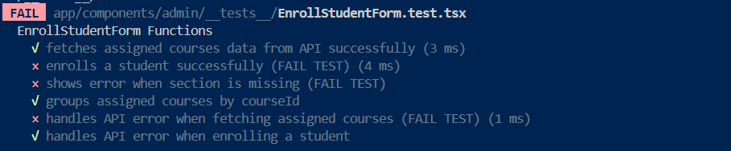

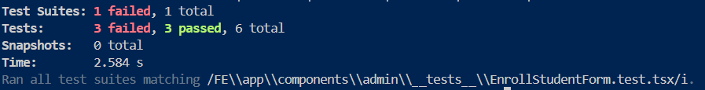

**Success:**

